

# Experiment 2

**Student Name: Archit Kaushal UID: 23BCS10313**

**Branch: B.E.CSE Section/Group: 23BCS-KRG-2B**

**Semester: 5th Date of Performance:28-07-25**

**Subject Name: ADBMS Subject Code:23CSP-333**

# Aim:

# You are a Database Engineer at TalentTree Inc., an enterprise HR analytics platform that stores employee data, including their reporting relationships. The company maintains a centralized Employee relation that holds: Each employee’s ID, name, department, and manager ID (who is also an employee in the same table).

# Your task is to generate a report that maps employees to their respective managers, showing:

# The employee’s name and department

# Their manager’s name and department (if applicable)

# This will help the HR department visualize the internal reporting hierarchy.

# You are a Data Engineer at FinSight Corp, a company that models Net Present Value (NPV) projections for investment decisions. Your system maintains two key datasets:

# Year_tbl: Actual recorded NPV’s of various financial instruments over different years:

# ID: Unique Financial instrument identifier.

# YEAR: Year of record

# NPV: Net Present Value in that year

# Queries_tbl: A list of instrument-year pairs for which stakeholders are requesting NPV values:

# ID: Financial instrument identifier

# YEAR: Year of interest.

# Find the NPV of each query from the Queries table. Return the output order by ID and Year in the sorted form.

# However, not all ID-YEAR combinations in the Queries table are present in the Year_tbl. If an NPV is missing for a requested combination, assume it to be 0 to maintain a consistent financial report.

# Objective:

# To understand how to use JOINS in SQL.

# To understand the basic SQL Queries.

# To generate hierarchical reports from self-referencing tables.

# DBMS script and output:

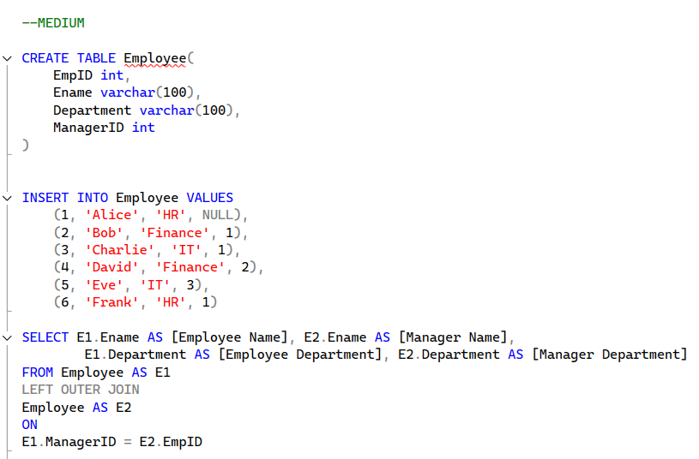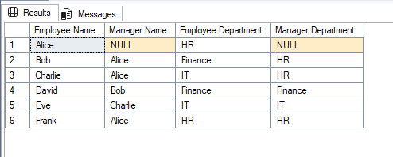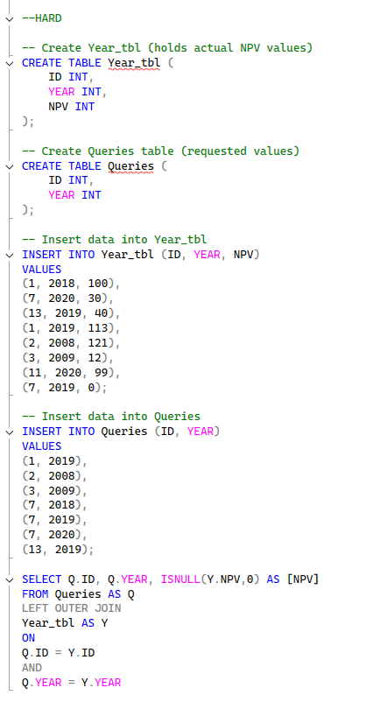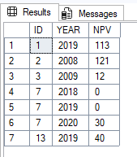

1. **Learning outcomes:**

* You will be able to write basic SQL queries.
* You will learn to perform JOINS in SQL.
* You will understand how to implement foreign keys.